Modeling Bipolar Devices Using the MEXTRAM Model
Introduction
The MEXTRAM bipolar model was recently released into the public domain by Philips Electronics N.V. and this model is now supported by UTMOST and SmartSpice. This article will give a very brief introduction to the MEXTRAM model. Some measured DC device characteristics will be modeled with the MEXTRAM equations and the results of this UTMOST parameter extraction experiment will be shown here.

The MEXTRAM Model
Accurate and reliable simulation of bipolar circuits require that the circuit simulator model in use can describe a large number of physical phenomena. The extended Gummel-Poon model, commonly used by circuit designers, often fails be meet the required accuracy criteria. The MEXTRAM equations model the following effects:
- Temperature effects
- Charge storage effects
- Substrate effects including the parasitic PNP
- High-injection effects
- Built-in electric field in base region
- Bias-dependent Early effect
- Low-level non-ideal base currents
- Hard and quasi-saturation
- Weak avalanche
- Hot carrier effects in the collector epilayer
- Explicit modeling of the inactive regions
- Split base-collector depletion capacitance
- Current crowding and conductivity modulation for base resistance
- First-order approximation of distributed high frequency effects in the intrinsic base (high-frequency current crowding and excess phase-shift).
Like most other bipolar models MEXTRAM does not contain extensive geometrical or process scaling rules. A multiplication factor does exist in the model for parallel transistor arrangements. In total the MEXTRAM model contains 39 parameters for the modeling of current and charge, 13 temperature scaling parameters, and 3 parameters in its noise model. The MEXTRAM model has five internal nodes and model computing times should be, on average, three times greater than if the Gummel-Poon model were used. Full details of the model equations are available elsewhere [1,2].

MEXTRAM Parameter Extraction Example
The following data was measured for an NPN bipolar device:
a) Forward Gummel Data
b) Reverse Gummel Data
c) IC versus VCE at 3 base current levels
d) IE versus VEC at 3 base current levels
The measured data is plotted in Figure 1. Local optimization strategies were used to extract the required DC parameters from this data. An entire parameter extraction procedure for the MEXTRAM model using capacitance, DC, and fT data can be found elsewhere [3] and the strategies used in this example were based on the DC portion of this procedure.
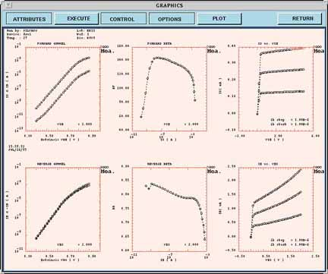
Figure 1. A complete measured data set for the NPN bipolar device.

Four local optimization strategies were implemented for the extraction of a partial parameter set for the MEXTRAM model. These are described in Table 1. Some parameter descriptions appear in Table 2.
Strategy | Steps | Parameters | Data
A | 4 | BF, IS, IBF, VLF | Forward Gummel (low and medium VBE levels)
 |  | BF, IK, RBC, RBV,  RE, VBE | Forward Gummel (high and medium levels)
B | 4 | BRI, ISS, IBR, VLR | Reverse Gummel (low and medium VBC levels)
 |  | BRI, IKS, RCC,  XEXT | Reverse Gummel high and medium VBC levels)
C | 1 | XCJC, BF (refine) | IC versus VCE
D | 1 | QBO, BRI (refine) | IE versus VEC
Table 1. Details of the UTMOST local optimization strategies used.

Parameter | Description
IS  BF  IBF  VLF  IK  RBC  RBV  RE  ISS  BRI  IBR  VLR  IKS  RCC  XEXT  XCJC  QB0 | Collector-emitter saturation current  Ideal forward gain  Saturation current of the non-ideal forward base current  Cross-over voltage of the non-ideal forward base current  High-injection knee current  Constant part of base resistance  Variable part of base resistance at zero bias  Emitter series resistance  Base-substrate saturation current  Ideal reverse current gain  Saturation current of the non-ideal reverse base current  Cross-over voltage of the non-ideal reverse base current  Knee current of the substrate  Constant part of collector resistance  Partitioning factor  Fraction of collector-base depletion capacitance under the emitter area  Base charge at zero bias
Table 2. A description of the extracted MEXTRAM parameters.

Strategy A involves the extraction of parameters to the forward Gummel characteristics. Using the UTMOST local optimization environment the collector and base current data was split up into various regions, four in all, and the associated parameters were extracted. In the second stage of the extraction procedure a similar analysis was performed on the reverse Gummel data. At this stage the majority of the parameters to be extracted to the DC characteristics were determined. In the final two local optimization strategies the parameters which model the forward and reverse early effects were extracted using the IC versus VCE and IE versus VEC data sets respectively. During these extraction stages the ideal forward and reverse gain parameters were also refined. The accuracy of the extracted MEXTRAM model surpasses that of a SPICE Gummel-Poon model derived from the same data. Improvements were most obvious in the modeling of the reverse characteristics.
The entire extraction process took less than 1 minute on a Sparc 2 computer and the results were good. Figure 2 shows the measured and simulated forward characteristics including a plot of the forward gain versus VBE. Figure 3 shows the measured and simulated reverse characteristics including a plot of reverse gain versus VBC.

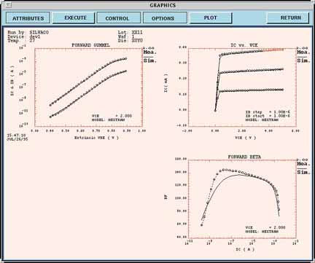
Figure 2. Measured (ooooo) and simulated (____) forward characteristics.

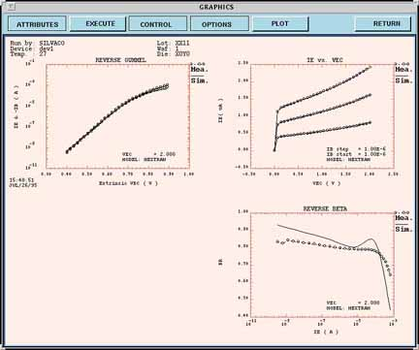
Figure 3. Measured (ooooo) and simulated (____) reverse characteristics.

Conclusions
This article has given an introduction to the Philips MEXTRAM bipolar model which has been implemented into SmartSpice and UTMOST. A very accurate model of measured device characteristics was obtained very quickly using some simple user-defined local optimization strategies.

Acknowledgement
SILVACO would like to thank Willy Kloosterman of Philips Research Laboratories, Eindhoven, The Netherlands, for his help during the course of this work.

References
[1] Nat.lab. Unclassified Report 006/94.
The Mextram Bipolar Transistor Model.
H.C. de Graff and W.J. Kloosterman.

[2] H.C. de Graff and W.J. Kloosterman,
"Modeling of the Collector Epilayer of a Bipolar Transistor
in the MEXTRAM Model,"
IEEE Trans. on Electron Devices, Vol. 42, No. 2,February 1995,
pp. 274-282.

[3] W.J. Kloosterman, J.A.M. Geelen and D.B.M. Klaassen,
"Efficient Parameter Extraction for the MEXTRAM Model"
to be published in the proceedings of the IEEE BCTM'95 conference.

